Your Guide to “Program Evaluation”

What is Program Evaluation?
The Program Evaluation allows a student to see their unofficial degree plan at any time and be sure that the courses they are taking will satisfy degree requirements for their major. It is intended to be an advising and planning tool and is not an official degree plan unless the Dean’s Office has reviewed it for the student and applied their “signature stamp” and saved it as a pdf document. (Not all colleges are yet using this as their official degree plan.)
Currently, Program Evaluation is available for undergraduate degrees in the 2012-2013 and 2013-2014 catalogs.

Where can I find Program Evaluation?
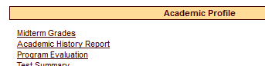
If you log into Buff Advisor, it can be found in the following places:
- Students Menu under Academic Profile listed as “Program Evaluation”
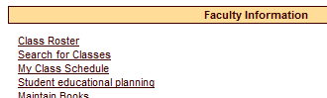
- Faculty Menu under Faculty Information listed under “Student Educational Planning”. Enter the Student ID and under Action* choose “EVAL”

How do I run the evaluation?
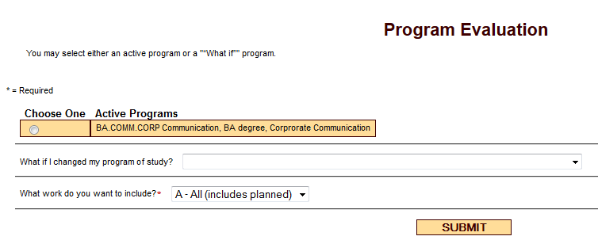
- Students
Click the circle if you want to run it against what is on record as your current major. If this isn’t your current major you need to complete a “Change of Major/Adviser” form with your adviser.
Choose a major from the dropdown box you are considering but haven’t yet declared.
Then click submit

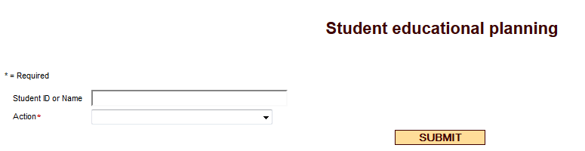
- Faculty
Enter the student’s WT ID, SSN or name
From the dropdown box, choose “EVAL – Evaluate Program”
Then click submit

Faculty then get the same page a student gets above.
Click the circle if you want to run it against what is on record as the current major. If this isn’t correct, complete a “Change of Major/Adviser” form with the student.
OR Choose a major from the dropdown box that is being considered.
Then click submit

Reading the Program Evaluation
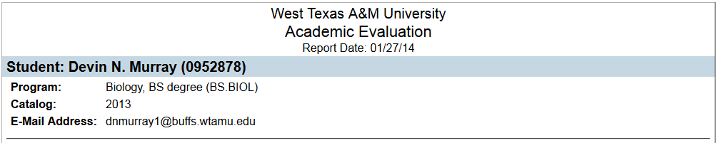
The header will include information on the student, major program and catalog year. Currently, the Evaluation is only available for the 2012-2013 and 2013-2014 catalogues.

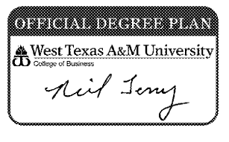
The evaluation is for advisement purposes. Some colleges are using it as the official degree plan once they have reviewed it for accuracy. If so, they will place a signature stamp on a pdf copy of the evaluation and from that point forward it is official and the student can follow it for required courses.
The Program Summary gives a quick view of the requirements and status of the program. The status will show (Complete) when all program requirements are met.
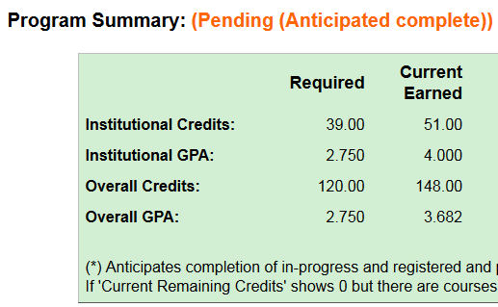


Below the Program Summary are the individual requirements for the specific major. The University Core Curriculum is listed first followed by the Major Requirements and then Electives (if any). This example shows Core 50 complete using a “Transfer Equivalency” (TE)* course from another college or university.
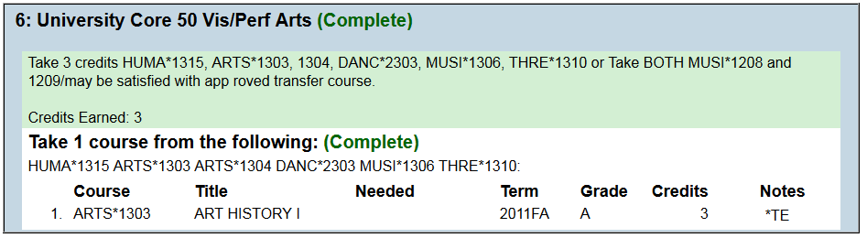
*A key to reading the “Notes” codes is printed at the bottom of the program evaluation.

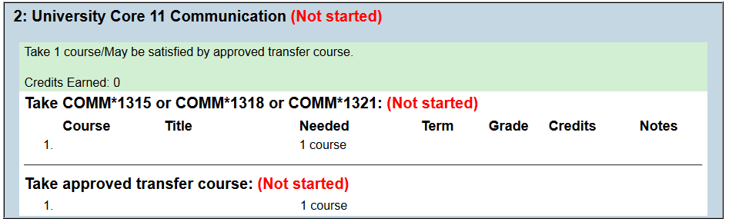
In this example, Core 11 is (Not Started). The student can choose 1 course from the 3 COMM courses listed OR they could take a transfer course at another school that is marked CORE 11 or is the exact equivalent to one of the 3 COMM courses. (See the Admissions Office for questions on approved transfer courses, OM 126, 806-651-2020.)

Some majors will require that a specific course is taken to fulfill both the Core and a major requirement. In that instance, a “placeholder” requirement is inserted that will show complete BUT the actual course and requirement will be listed down under the major area.
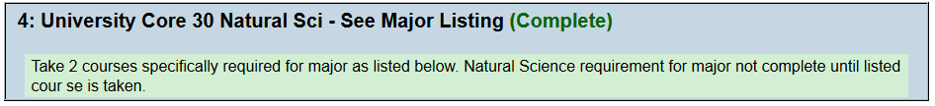
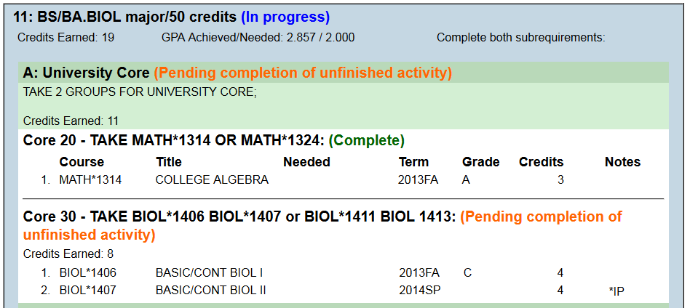
Here a student is a Biology Major and for the Core 30 Science requirement, specific BIOL classes are required. The first block shows the Core 30 listing and then below it is where the requirement is specifically listed in the Major area.

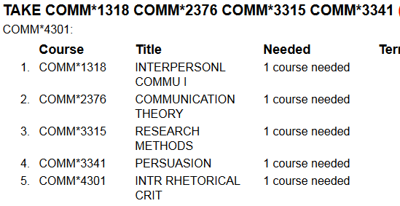
There are 3 options often seen on a program evaluation:
- Take all courses in a list of courses –

- Take a certain number of courses from a listing –
- Take a certain number of credits (or hours) in a subject or from a listing of courses -
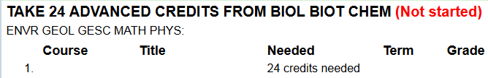

Sometimes a Dean will approve a substitution or exception allowing a student to use another course they have taken in place of one of the required courses. In that instance, the substitution is identified with that course requirement block.
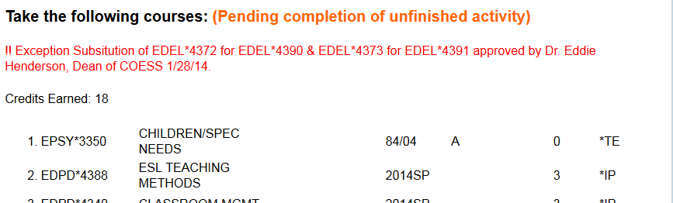

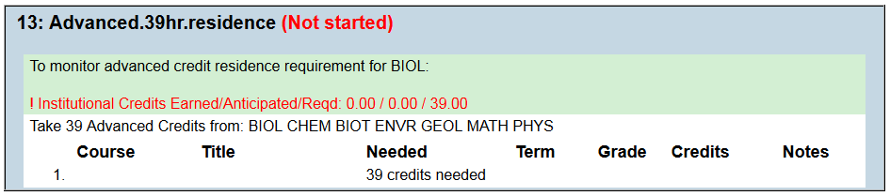
All undergraduate degrees at West Texas A&M University require that a student complete 39 advanced hours in residence. To track this, a block or placeholder is included in the program evaluation which “counts” these hours. These courses are counted to meet requirements in the sections above if they were degree requirements.

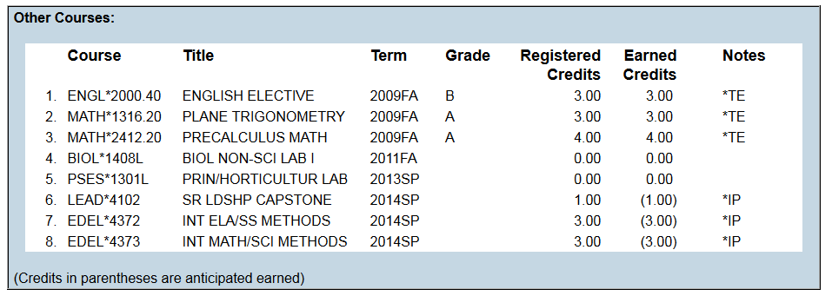
Below the residence credit block is a listing of “Other Courses” that have been taken but do not satisfy any of the requirements for the program being evaluated.

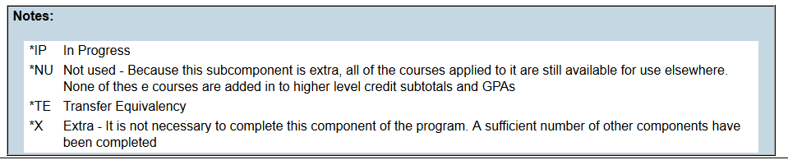
At the very bottom of the evaluation is a “Notes” Key which will provide a description of each “Notes” code used on this evaluation. The “Notes” Key is created for each individual evaluation based upon the codes used.

Questions about how credit has been applied to your Program Evaluation should be directed to the appropriate academic Dean’s Office.
College of Agriculture, Science & Engineering, ANS 106, 806-651-2585
College of Business, CC 216, 806-651-2530
College of Education & Social Sciences, OM 410, 806-651-2600
College of Fine Arts & Humanities, MMNH 161, 806-651-2777
College of Nursing & Health Sciences, OM 402, 806-651-3500

